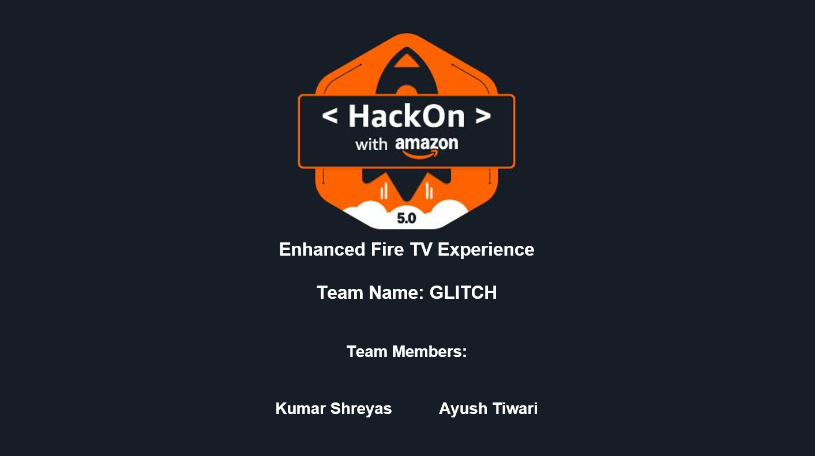

AI-Driven Recommendations and Social Watching on Fire TV

# Problem Statement and Define Scope of Your Innovation

## Problem Statement

Fire TV’s current passive content aggregation architecture creates significant user friction through fragmented discovery experiences and rudimentary recommendation algorithms that rely solely on viewing history while ignoring dynamic contextual signals like mood, temporal patterns, and environmental awareness. This results in users spending 18-23 minutes browsing before content selection, with 15-20% of sessions ending without consumption, while the lack of native social viewing infrastructure forces users to coordinate shared entertainment through external channels, missing opportunities to establish Fire TV as a social entertainment hub. These limitations create measurable business risk through reduced advertising revenue, lower OTT partner subscription retention, diminished user lifetime value, and below-benchmark NPS scores for content discovery, positioning Fire TV vulnerably against competitors with superior AI-driven personalization and social features. The strategic imperative requires developing a comprehensive AI-driven personalization and social engagement platform that transforms Fire TV into a proactive, emotionally intelligent entertainment companion through real-time context-aware recommendation engines synthesizing multimodal inputs (mood inference, temporal patterns, IoT signals, calendar data) to reduce discovery time by 60% and increase engagement by 40%, while implementing native social co-viewing infrastructure with synchronized playback, real-time communication, and AI-moderated interactive experiences. The solution encompasses cross-platform content aggregation, scalable cloud-native microservices architecture, and privacy-compliant data integration, positioning Amazon to capture nextgeneration smart entertainment opportunities and maintain competitive differentiation in the evolving streaming landscape.

## Scope of Innovation

### Real-Time Context-Aware Recommendations

We are introducing a dynamic personalization engine that extends beyond traditional content filtering. It will integrate multiple data sources to infer the user’s current context, including:

* + Historical behavioral data: watch history, engagement patterns, and completion rates.
  + Mood inference: via voice tone, facial cues (if available), and biometric signals from wearables.
  + Temporal awareness: mapping content preferences to time-of-day, day-of-week, and calendar events.

The AI-powered recommendation engine dynamically personalizes content based on mood, time-of-day, calendar events, and behavioral history to improve discovery efficiency and session engagement across Fire TV. A real-time context engine processes multimodal inputs (e.g., voice tone, facial expression, wearable data, smart home signals) to adapt recommendations to the user’s emotional and environmental state, increasing content relevance. By combining these inputs, the system delivers contextually relevant, emotionally intelligent recommendations that adapt in real-time — significantly reducing search friction and improving user satisfaction.

### Integrated Social Co-Viewing Experience

Our platform will support synchronized playback, real-time chat, and shared reactions, enabling users to co-watch content with friends and family across locations. Core features include:

* + Session orchestration with synchronized controls.
  + Group mood alignment to balance content selection for multiple viewers.
  + An optional AI-driven session host that enhances engagement through contextual trivia, polls, and guided interactivity.

The social co-viewing module enables synchronized playback, chat, and reactions for remote users to replicate the communal TV experience virtually, resulting in deeper engagement and higher retention rates. An AI session host assistant curates interactivity (e.g., trivia, polls, content highlights) during watch sessions to enrich viewer engagement and differentiate the platform’s social features, especially during hightraffic periods. This feature set positions Fire TV as a social hub for entertainment, rather than a solitary consumption device.

### Cross-Platform Content Aggregation (Subject to API Access)

To maximize personalization breadth, the system is designed to integrate with OTT platform APIs (where accessible), enabling:

* + Centralized metadata ingestion and normalization across providers.
  + Unified user behavior modeling to deliver platform-agnostic recommendations.
  + Cross-service social viewing sessions — a unique differentiator in the current OTT landscape.

Cross-platform content aggregation, where OTT APIs permit, unifies watch data and metadata to deliver consistent recommendations across services, reducing fragmentation and discovery fatigue.

### Environmental and Intent-Aware Signal Integration

The recommendation engine will incorporate ambient and contextual cues from connected ecosystems, including:

* + Smart home devices: lighting, sound environment, and temperature.
  + Google Calendar & Photos: for interpreting mood and intent based on upcoming events or recent experiences.

Environmental and intent-aware integration, including Google Calendar, Google Photos, and IoT signals, enables proactive content delivery aligned with user schedules and recent life events, boosting contextual satisfaction.

# Working Backwards from Customer and Define Who is Your Customer

## Customer Segmentation & Behavioral Analysis

### Primary Customer Archetypes:

* + **The Overwhelmed Browser** (35% of user base): Professional millennials and Gen-X users (ages 28-45) experiencing decision paralysis when confronted with endless content options across multiple streaming services. High engagement intent exists but discovery efficiency remains compromised, with sessions frequently abandoned due to cognitive overload rather than lack of interest. Consistent viewing patterns emerge during specific time windows (weekday evenings 7-10 PM, weekend afternoons) with preferences gravitating toward curated, contextually relevant recommendations that align with current emotional state and available viewing time.
  + **The Social Connector** (25% of user base): Distributed families and friend groups prioritizing shared entertainment experiences while remaining fragmented across communication platforms. This segment encompasses parents maintaining connections with adult children, long-distance relationships, and remote work colleagues seeking social bonding through entertainment. Willingness to coordinate viewing schedules and active engagement in real-time commentary during content consumption characterizes this highest lifetime value segment due to their influence on group viewing decisions and content discovery.
  + **The Contextual Consumer** (40% of user base): Tech-savvy users expecting intelligent, ambient computing experiences that adapt to lifestyle patterns. Multiple connected devices, maintained digital calendars, and sophisticated content prefer- ences varying based on temporal, emotional, and environmental factors define this segment. Early adopters of smart home technology anticipating seamless integration between entertainment choices and broader digital ecosystem comprise this category.

## Customer Needs, Pain Points & Frustrations Analysis

### Core Frustrations Identified:

* + **Decision Fatigue & Time Waste:** Current Fire TV experiences generate anxiety rather than relaxation, with precious leisure time consumed by endless browsing across fragmented content catalogs. The paradox of choice creates stress where relaxation was intended, leading to frequent session abandonment without content consumption.
  + **Social Coordination Friction:** Technical setup barriers consistently discourage group viewing sessions, forcing manual coordination across multiple communication platforms. Desired shared experiences become logistical challenges, diminishing spontaneous social entertainment opportunities and reducing overall platform engagement.
  + **Contextual Blindness:** Entertainment systems remain oblivious to user context, mood, available time, or current circumstances, delivering generic recommendations that ignore situational relevance. Users express consistent desire for systems that “understand them” and proactively suggest contextually appropriate content.
  + **Cross-Platform Fragmentation:** Content discovery occurs in silos across multiple OTT platforms, creating redundant search efforts and incomplete viewing behavior understanding. Users experience cognitive load managing multiple subscription interfaces with inconsistent personalization quality.

## Desired Customer Experience Flow

**Target Customer Outcome:** Transition from “I want to watch something” to “I’m engaged with perfect content” within 60 seconds, with optional seamless social experience sharing.

### Experience Progression:

1. **Contextual Recognition Phase:** Fire TV activation triggers instant environmental signal analysis (time of day, calendar events, smart home device states, historical patterns) inferring user intent and emotional state. Multimodal data fusion pipelines process wearable biometrics, voice tone analysis, and ambient environmental data generating contextual user profiles in real-time.
2. **Intelligent Content Curation Phase:** Contextual analysis drives presentation of 3-5 highly relevant content options within 10 seconds of activation, accompanied by brief context explanations (“Based on your relaxed evening routine” or “Perfect for your 45-minute window before your next meeting”). Sophisticated ML models process historical behavioral data, current context signals, and cross-platform content metadata generating personalized recommendations with explainable reasoning.
3. **Frictionless Social Integration Phase:** Social viewing selection enables one-click invitation sending through preferred communication channels, automatic session synchronization, and ambient social features (reactions, comments) enhancing rather than distracting from content consumption. Distributed synchronization systems handle variable network conditions while maintaining seamless playback coordination across multiple devices and locations.
4. **Adaptive Engagement Enhancement Phase:** AI system subtly enhances viewing session engagement through contextual information delivery (actor trivia, location details, related content suggestions) with optional user engagement. Real-time content analysis, knowledge graph integration, and user preference learning algorithms adapt interaction frequency and type based on individual engagement patterns.

## Working Backwards Technical Architecture

**Customer Experience Requirements Driving Technical Implementation:** Cloud-native microservices architecture processing millions of concurrent contextual signals while maintaining sub-second recommendation response times and coordinating real-time social viewing sessions across distributed users becomes foundational. Advanced ML model deployment pipelines, real-time data streaming infrastructure, and privacy-compliant user data management systems enable sophisticated personalization while maintaining strict data protection compliance. Integration points accommodate existing Fire TV hardware limitations while providing upgrade paths for enhanced functionality as device capabilities evolve.

### Architecture Components Mapped to Customer Value:

* + **Real-time Context Engine:** Processes multimodal input streams (calendar APIs, IoT device telemetry, biometric data, environmental sensors) generating dynamic user context profiles enabling predictive content curation aligned with user intent and emotional state.
  + **Distributed Recommendation Service:** Aggregates cross-platform content metadata, user behavioral history, and contextual signals through sophisticated ML pipelines delivering personalized content suggestions with explainable reasoning and temporal relevance optimization.
  + **Social Synchronization Infrastructure:** Coordinates multi-user viewing sessions through distributed consensus algorithms, real-time media synchronization, and ambient communication channels maintaining seamless shared experiences across variable network conditions and device capabilities.
  + **Privacy-Compliant Data Management Layer:** Implements federated learning architectures and differential privacy techniques enabling sophisticated personalization while maintaining user data sovereignty and regulatory compliance across global privacy frameworks.

# What Are Your Success Metrics and What’s the impact of Your Solution

* + **Time-to-Value (TTV):** Reduce average time from Fire TV activation to content play from 18–23 minutes to under 60 seconds. Measured by tracking timestamped user session data — specifically, the delta between app launch and playback initiation — and averaging it across cohorts (e.g., new users, returning users, feature adopters). Monitor the drop-off rate between the home screen and playback screen to identify friction points.
  + **User Retention and Session Engagement:** Target a 25–35% uplift in 30-day retention and aim to reduce session abandonment (currently at 15–20%) to under 5%. Captured through user login/activity logs, segmented by feature engagement and behavior archetype.
  + **Feature Adoption and Innovation Uptake:** At least 50% of active users to use one or more new AI-driven features (e.g., mood-based suggestions, co-viewing, calendar-aware curation) within their first 90 days. Measured via backend feature flag instrumentation and usage event logging, coupled with time-bound funnel analysis.
  + **Social Engagement:** Users in the “Social Connector” segment to participate in at least two co-viewing sessions per week. Tracked through session coordination logs, number of invited participants, interaction counts, and session durations. Realtime synchronization stability and playback consistency across devices will also be tracked.
  + **Customer Satisfaction and Advocacy:** Aim for a +30-point NPS lift within six months of launch. Collected using in-app micro-surveys, post-session feedback prompts, and integrated survey APIs — with data segmented by feature usage and viewing context.
  + **Business Value and Partner Alignment:** Measured by a 40% increase in OTT partner content engagement and a 15–20% drop in user churn. Platform-side analytics to track watch time, completion rate, and scroll depth for each OTT content source, mapped against the influence of our recommendation system. Churn metrics derived from login frequency trends, subscription retention data, and inactivity detection via platform telemetry.
  + **User ‘Aha!’ Moments:** Logged as experience validations and fed into continuous discovery loops for product improvement, using natural language tagging and sentiment analysis from in-app feedback.
  + **Delivery Velocity and Execution Health:** Monitored with agile delivery metrics — story throughput, epic burn-down, release readiness scores, and deviation from planned delivery (targeting ¡10% timeline variance).

### Impact of the Solution:

The proposed AI-driven personalization and social engagement system introduces a fundamental shift in the Fire TV experience by embedding real-time contextual intelligence, cross-platform recommendation logic, and distributed social synchronization directly into the platform architecture. From a user experience perspective, the solution mitigates decision fatigue and session abandonment by reducing time-to-content from 18–23 minutes to under 60 seconds, while delivering highly personalized recommendations based on mood inference, behavioral history, and temporal context. For socially oriented users, the integrated co-viewing infrastructure enables synchronous playback, in-session communication, and group mood alignment — transforming Fire TV into a shared virtual environment rather than an isolated consumption device. Technically, the impact extends across multiple operational dimensions: the system leverages a modular, microservices based architecture with real-time data pipelines, scalable ML model deployment, and differential privacy frameworks to ensure performance, extensibility, and compliance at scale. On the business front, the solution is expected to increase OTT partner content engagement by 40%, reduce user churn by 15–20%, and significantly improve customer satisfaction metrics, including a targeted +30 uplift in Net Promoter Score. Most importantly, the platform lays the foundation for Fire TV to transition from a reactive interface to a proactive, intent-driven entertainment layer — capable of continuous learning, emotional adaptation, and multi-user engagement across diverse contexts and device ecosystems.

# Scope for Scalability and marketplace Domain expansion

## Scope for Scalability

### Architectural Design for Scalability

* + Modular Microservices Framework: The system employs a cloud-native microservices architecture, which segments functionalities such as the real-time context engine, recommendation algorithms, and social synchronization into independently deployable services. This modularity facilitates targeted scaling, ensuring resources can be optimized for demand spikes in specific areas without overprovisioning the entire system.
  + Elastic Cloud Infrastructure: Leveraging elastic cloud services enables dynamic resource allocation, allowing the platform to automatically adjust compute, storage, and network capacity based on real-time user load, ensuring seamless user experiences even during peak traffic.

### Performance and Responsiveness

* + Sub-second Latency: The design prioritizes ultra-low latency responses for personalized recommendations and social interactions, crucial for maintaining user

engagement and delivering fluid, contextually relevant experiences in real time.

* + High Concurrency Handling: The infrastructure supports millions of concurrent contextual events and interactions, ensuring Fire TV can serve a large, diverse user base simultaneously without performance degradation.

### Machine Learning Operations (MLOps) and Continuous Improvement

* + Continuous Model Deployment: Advanced ML models powering personalization are integrated into automated pipelines allowing continuous updates, A/B testing, and rollout strategies. This enables quick iteration cycles to adapt to changing user behaviors and preferences.
  + Adaptive Learning Systems: Leveraging real-time data streams, the system continuously refines recommendation quality and social context detection, ensuring relevance and personalization improve as more user data is collected.

### Privacy, Security, and Compliance at Scale

* + Federated Learning & Differential Privacy: To address stringent global privacy regulations (GDPR, CCPA), the platform employs federated learning techniques that keep raw user data decentralized while still benefiting from aggregated model training. Differential privacy ensures individual user signals are anonymized, fostering trust and regulatory compliance without sacrificing personalization depth.
  + Data Governance Framework: Robust controls for data collection, storage, and processing protect user privacy and data security, reducing risks and aligning with Amazon’s broader compliance and security standards.

### Extensibility and Ecosystem Integration

* + Multi-Device and IoT Integration: The scalable architecture supports seamless integration of emerging IoT devices, wearables, and third-party APIs (e.g., calendars, photos), enriching contextual signals and broadening the personalization scope.
  + Platform Agnosticism and Open APIs: Designed to allow easy onboarding of new data sources and third-party services, ensuring future-proofing and adaptability to evolving ambient computing paradigms.

## Marketplace Domain Expansion

### From Streaming to Social Entertainment Ecosystem

* + Cross-Platform Content Aggregation: By integrating multiple OTT services through API access, Fire TV transcends siloed content experiences. Users benefit from unified search, discovery, and social co-viewing capabilities across subscriptions, greatly enhancing convenience and value.
  + Unified Content Discovery: AI-driven recommendations combine data across content providers to present holistic, mood and context-aware entertainment options, improving content relevance and discovery efficiency.

### Social Co-Viewing and Community Engagement

* + Synchronous Remote Viewing: The platform addresses a growing demand for shared viewing experiences despite physical distance, offering seamless synchronization, chat, and reaction features that replicate the social dynamics of in person entertainment.
  + Niche and Broad Social Communities: Targeting diverse user groups—from family units to specialized interest communities—this feature expands Fire TV’s appeal as a social entertainment hub, fostering stickiness and daily active engagement.

### Strategic Partnerships and Ecosystem Growth

* + OTT and Smart Home Collaborations: Fire TV can leverage partnerships with content providers, smart device manufacturers, and social media platforms to create bundled offers and cross-promotions, driving user acquisition and retention.
  + Co-Marketing and Bundled Services: Collaborative marketing efforts and bundled subscription packages create additional revenue streams and enhance brand positioning within competitive entertainment and smart home markets.

### Monetization and Revenue Growth

* + Advertising Revenue Enhancement: Personalized, context-aware ad targeting increases engagement rates, providing higher ROI for advertisers and growing Fire TV’s ad revenue.
  + Subscription Retention and Upselling: Richer engagement via social and AI features fosters higher subscription renewal rates and opens opportunities for premium feature upselling.

### Strategic Alignment with Amazon’s Vision

* + Next-Generation Smart Entertainment Leadership: These marketplace innovations position Fire TV as a frontrunner in the evolving entertainment landscape, aligning with Amazon’s ambition to lead in smart, socially connected, and ambient entertainment experiences.
  + Customer Loyalty and Diversified Revenue: By deepening emotional connections through AI personalization and social features, Fire TV strengthens long-term customer loyalty while diversifying revenue beyond traditional streaming subscriptions.

# Architecture

## Architectural Patterns (Domain-Driven, Tech-Heavy)

### Microservices Architecture with Domain-Driven Design (DDD)

* + - Bounded Contexts encapsulate key domains:
      * Content Aggregation & Multi-OTT Adapter Microservice: Implements API gateway facade for heterogeneous OTT APIs, employing circuit breakers (Hystrix/Resilience4j) for fault isolation.
      * Real-Time Context Engine Microservice: Stateful service using event sourcing and CQRS (Command Query Responsibility Segregation) to segregate write/read workloads, powered by Apache Flink or Kafka Streams for continuous stream processing.
      * Social Synchronization Microservice: WebSocket-based real-time bi-directional communication, leveraging gRPC for inter-service RPC calls; employs distributed consensus protocols (e.g., Raft) to maintain consistent playback state across sessions.
      * Marketplace Microservice: Implements eventual consistency with saga patterns for orchestrating complex distributed transactions (e.g., cross-platform bundling, multi-provider subscriptions).
      * User Identity & Consent Microservice: Implements OAuth 2.0/OpenID Connect for federated authentication, supports attribute-based access control (ABAC) for fine-grained authorization.

### Service-Oriented Architecture (SOA) with Reusable Enterprise Services

* + - Stateless services for:
      * Notification Service: Supports push notification brokers (Firebase Cloud Messaging, APNs), leveraging publish-subscribe messaging for event dissemination.
      * Analytics & Logging Service: Employs ELK stack (Elasticsearch, Logstash, Kibana) for real-time monitoring and anomaly detection with machine learning anomaly detection algorithms.

### Event-Driven Architecture (EDA) with Asynchronous Messaging

* + - Utilizes Apache Kafka as the central event streaming platform with topic partitioning for high throughput and scalability.
    - Implements event schema registry for backward-compatible event evolution.
    - Supports dead-letter queues (DLQ) to isolate and debug failed event processing.

## Infrastructure Components (Enterprise-Grade, Cloud-Native)

### Load Balancers & API Gateway

* + Layer 7 Application Load Balancers (AWS ALB, NGINX) for content-based routing and SSL termination.
  + Kong or Ambassador API Gateway for API composition, throttling, and security enforcement with JWT validation and rate limiting policies.

### Distributed Caching Layer

* + Multi-tier cache architecture:

∗ CDN (Akamai, Cloudflare) for global static asset caching and streaming acceleration.

∗ Redis Cluster as distributed in-memory cache for session state and feature flagging with TTL expiration and cache invalidation strategies.

∗ Content-based cache keys for personalized user content.

### Message Queues & Event Brokers

* + Kafka clusters with Zookeeper for distributed coordination, leveraging log compaction for critical event streams.
  + RabbitMQ for guaranteed message delivery with acknowledgements and retries, especially for transactional workflows in the marketplace domain.

### Distributed Databases & Data Stores

* + Cassandra or ScyllaDB for horizontally scalable user and event data with multi-region replication and tunable consistency levels (QUORUM, ALL).
  + CockroachDB or Google Spanner for ACID-compliant transactional marketplace data supporting distributed SQL and geo-partitioning.
  + Data Lake on AWS S3 or Azure Data Lake for raw event logs, integrated with Apache Spark for batch analytics.

### Content Delivery Networks (CDNs)

* + Multi-CDN strategy for global redundancy, employing DNS load balancing to reduce latency and improve resilience.

## Scalability and High Availability

* Horizontal Pod Autoscaling (Kubernetes): Metrics-driven autoscaling using Prometheus metrics (CPU, memory, custom application metrics like active sessions). Cluster autoscaler to dynamically add/remove nodes on cloud providers (EKS, GKE, AKS).
* Vertical Scaling & Resource Optimization: Use of vertical pod autoscaling to adjust container resources dynamically. Profiling with eBPF tools to monitor system calls and resource bottlenecks.
* Fault Tolerance & Resilience Engineering: Implement circuit breaker patterns and bulkheads to isolate failures. Use chaos engineering tools (Chaos Monkey, Litmus) to validate system robustness under failure scenarios.
* Disaster Recovery & Multi-Region Failover: Active-active deployment across multiple cloud regions with geo-replication of databases and caches. Automated failover orchestrated via service mesh (Istio/Linkerd) with canary deployments for zero downtime releases.

## Observability (Comprehensive Monitoring & Logging)

* Monitoring Stack: Prometheus + Grafana for infrastructure and application metrics. OpenTelemetry for distributed tracing across microservices, capturing request latencies, error rates, and dependency maps.
* Centralized Logging and Analytics: ELK stack enhanced with Logstash filters and Kafka Connect for scalable log ingestion. Security Information and Event Management (SIEM) integration for real-time threat detection.

## Security Framework (Zero Trust & Compliance)

* Identity & Access Management (IAM): Role-Based Access Control (RBAC) combined with Attribute-Based Access Control (ABAC) for dynamic policy enforcement. Use of Hardware Security Modules (HSMs) or cloud KMS for encryption key management.
* Network Security: End-to-end encryption with mTLS (mutual TLS) between microservices. Web Application Firewalls (WAF) and Intrusion Detection/Prevention Systems (IDS/IPS) protecting APIs and data endpoints.
* Data Protection: Data-at-rest encryption using AES-256, and data-in-transit encryption enforced via TLS 1.3. Use of tokenization and data masking for sensitive PII and payment data in marketplace transactions.

## DevOps & Configuration Management

* Infrastructure as Code (IaC): Use Terraform and Helm charts for declarative infrastructure and Kubernetes deployment automation. GitOps workflows with ArgoCD or Flux for automated continuous delivery.
* Continuous Integration / Continuous Deployment (CI/CD): Pipelines built with Jenkins, GitHub Actions, or GitLab CI integrating unit, integration, and security

tests (SAST/DAST). Use blue-green deployments to minimize user impact during releases.

* Performance Engineering: Load testing using tools like JMeter and Locust simulating concurrent co-viewing sessions and marketplace surge scenarios. Profiling backend services with APM tools (New Relic, Datadog) for pinpointing bottlenecks.

# System’s Architecture

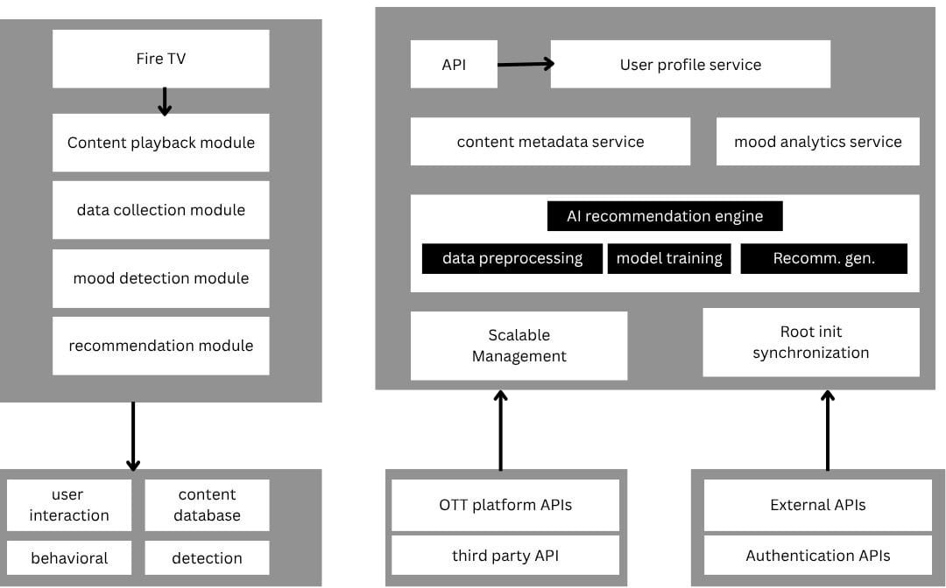

Figure 1: Overview of the system’s architecture.

## Data Flow Summary

User interactions on the Fire TV app generate behavioral and mood data, which is sent to backend services. This data, along with content metadata, feeds into the AI Recommendation Engine to generate personalized suggestions. For social watching, the Fire TV app communicates with the Social Watching Coordination Service to synchronize playback and facilitate real-time chat among participants.

# Others(if any)

### Key Considerations and Future Enhancements:

* + Privacy and Data Security: Implementing robust data encryption, anonymization, and strict access controls is paramount, especially when dealing with sensitive data like mood and viewing habits. Clear user consent mechanisms are essential.
  + Ethical AI: Ensuring fairness and transparency in recommendation algorithms to avoid biases and filter bubbles. Users should have some control over their recommendation preferences.
  + Hardware Requirements for Mood Detection: Real-time facial emotion detection would ideally require a camera connected to or integrated with the Fire TV device. This might be a limiting factor for widespread adoption and would need clear communication to the user.
  + OTT Platform Collaboration: The success of cross-platform content aggregation and personalized recommendations heavily relies on the willingness of OTT providers to expose relevant APIs and data. Building strong partnerships would be beneficial.
  + User Onboarding and Education: Clearly communicating the benefits of personalized recommendations and social watching, and guiding users through the setup of mood detection (if implemented), will be crucial for adoption.
  + Monetization Strategy: While the initial focus is on user experience, future monetization could involve premium social features, enhanced content discovery tools, or targeted advertising based on deep user insights (with privacy considerations).
  + Accessibility: Ensuring the application is accessible to users with disabilities, adhering to accessibility guidelines for TV applications.